
MGH JFL Board of Trustees
Meeting Agenda – Sunday, August 17th @ 6:00pm
Location: Blue Margaritas
105 Elizabeth Pointe Dr., Germantown Hills, IL 61548
Call to Order
Chris made a motion to call the meeting to order @ 6:02 pm. Motion was 2nd by Kyle. Motion passed unanimously.
Attendance
2024-2025 MGH JFL Board of Trustees Members
Position | Name | Attendance
President | Brad Grebner | X
Vice President/Fundraising | Tim Woelfel | X
Finance Director | Jarrad Koon | X
Secretary / Assistant Cheer Director | Amy Duffield | X
JFL OCI Director | Brad Grebner | X
Coaches Director | Chris Smith | X
Cheerleading Director | Jessica Kelly | X
Site Manager | Charlie Jackson | X

Assistant Equipment | Kyle Durst
Equipment | Dave Thompson | X
Assistant Equipment | Dakota Dealey
Concessions | Abbie Tabor | X
Assistant Concessions | Janel Davis | X
IT/Communications Director | Kyle Lavery | X
Flag Director | Pete Schultz | X
Member | Jeremy Whitman
Member | Jason Mulvaney | X

Guests: None
MGH JFL Board of Trustees Meeting
President & JFLOCI Report (Brad Grebner)
Motion to Approve July meeting minutes:
● Motioned: Tim
● Motioned 2nd: Charlie
● Vote Results: Approved Unanimously
Game Cameras – Desire to order 5x xbox go camera kits (camera for use with cellphone, case, 13’ tripod, etc) @ ~$500.00 each – Total ~$2,500
Building Cameras – Status of building cameras- this is still in process.

Storage Shed For Practice Equipment – Desire to order storage shed for the park to store practice equipment and pads out be practice fields. See complete list of designs in Appendix.
Option 1 – 12’x24’ Lofted Garage – Painted $9,920 – Metal $11,460
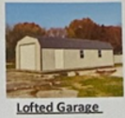
Option 2 – 12’x24’ Portable Garage – Painted $8,285 – Metal $9,615
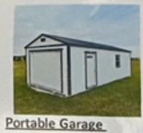
Option 3 – 12’x24’ Barn – Painted $6,700
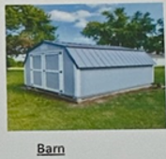
We need to talk to the park district to see if they have any restrictions on putting a shed at the park or restrictions on the type/design of the shed.
Kyle made a motion to purchase a shed not to exceed $15,000. The motion was 2nd by Charlie.
Motion was passed unanimously.
Finance (Jarrad Koon)
Checking Account Balance - $118,000
OCI Account - $22,000
OCI Fees
$25cheer x 59 = $1,475, $130 tackle x 142 = $18,460 , $0 flag x 50 = $0 for TOTAL = $19,935

Fundraising (~89% goes to equipment fund) - $100 per participant x 251 participants = $25,100 @ 89% = $22,339

8/13/2025 - $117,810 - $44,990 = $72,775

Board Approved Expenses: $2,500 building cameras, $1,500 cheer equipment - $68,775 in checking after expected expenses, OCI fees, and Fundraising comes out. ~$22,339 on top of what is already in OCI equipment fund

Tax Update:
● 2025 Annual Report Filed
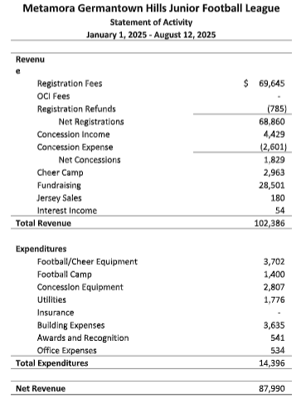
Coaches Director (Chris Smith)
Training Status - Complete

Coach’s hats have arrived and will be handed out by Chris

Badges will be handed out once Brad receives them from OCI.

If a coach did not do the coaches training, we will be charged $50 if these coaches are caught coaching. We as an organization will not be paying the fine for coaches who didn’t complete the training.

Fundraising/ Vice President (Tim Woelfel)
Fundraising
o Redbird Cards Submitted for printing - Complete

Fundraising tickets & Redbird Cards – Handed out. To be returned to head coach by Thursday August 28th.

Advertising Signs – KNZ, Dumpster Dude, Salon Seven, Martin Signs - Ordered

Discussed purchasing pink jerseys for all players/cheerleaders for the month of October. This purchase is being made per the request from a donation made to the program.
Chris made a motion to purchase enough jerseys for all kids in the program. Motion was 2nd by Pete
Motion passed unanimously.
Site Manager (Charlie Jackson)
Upstairs work near completion
Kitchen work near completion
Bathroom Exhaust Fans – humidity is so high in the building causing mold. We need to do some pricing on this.
- Could range between $500 to $2,000
Sofit to be finished
Field Maintenance – 3x irrigation valves to be fixed
Equipment (Dave)
Flag Jersey Plan – Have been ordered and have arrived; Hand out date?
Any other equipment needs?
Cheer Director (Jessica Kelly)

Warm-ups and extra shell tops are being looked into. Jess is working with Varsity and Rebel to design shell tops as Varsity has discontinued to shell top that currently is being used.

Tim & Jess will develop charter for growth in 2026
Cheer Wants/needs:
Floor length mirror for cheer room
Hanging rods/hangers to hang uniforms/warmups

Rubel wants to sponsor- purchase football to throw out, Jess to message Tim and Brandy
Concessions (Abbie Tabor)
Concessions
- Picnic Tables – Tim has emailed MTHS- the shop class is going to start designing the picnic tables and will give us a supply list of things that will need to be purchased.

OK’d to order oven, freezer and machines to arrive the week of kickoff – These have arrived and all worked well for the kick off weekend.
Abbie states that she feels that she is pretty much all set up for the fall season to being.
Volunteers:
MTCO Park pays $15/hr w/ no grill
Pete made a motion for Abbie to hire up to 2 paid staff for a tackle weekend. Charlie second the motion, Approved Unanimously.
Abbie will come up with a list of people to hire when called up

Discussed purchasing a split unit for the concession stand. Jarred made a motion to purchase 2 units. Motion was 2nd by Chris.
Kick off night:
Dunk Tank- $206 made- cost $150 to rent
Sales- $1,600 in sales from Kick off

Boys of Fall (Sept 27th) If people by tickets for Boys of Fall through the flyer we have, we will get $2 back. JFL will be cooking at the event again this year.
Flag Director- (Pete)
Things are going well, practices have started.
IT/Communications- (Kyle)
Updates needed – Important Dates Updated; Add Dumpster Dude to website for sponsor
New Business Discussion
Going to pull the trophies down from the concession stands. Going to put up a menu and tvs with scrolling pictures of kids and of the sponsors.
MTHS kick off night- 12U and 14U will be scrimmaging at 3pm. Cheerleaders will be cheering during the scrimmage. We need to send out a mass email about timelines.
Adjournment
● Chris made a motion to adjourn the meeting at 7:23pm. Motion 2nd by Pete. Motion passed unanimously.
Next Meeting
Sunday, September 21st @ TBD
Action Items
Action Items: | Owner(s): | Deadline :

Concessions Director Report
Flag Director Report
JFL Storage Shed List
